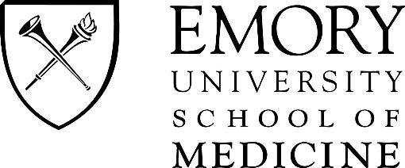
Please check the program you are applying to:

- Anesthesiologist Assistant
- Medical Imaging
- Genetic Counseling
- Physical therapy
- Physician Assistant

INTERNATIONAL VISITING STUDENT APPLICATION FORM

Read and follow each step carefully and see the checklist on page 3 of this application for further guidance. Incomplete or incorrect applications will not be considered.

For international visiting students, a non-refundable application fee of $500.00 in the form of a check or money order, payable to Emory University School of Medicine must accompany this application. (U.S. currency only - No International Checks) International students who are accepted to an Emory Elective will be required to pay an additional $3,600.00 tuition fee per elective with a maximum of two electives

Completed Health Forms must be mailing separately to: Emory University Student Health Services, 1525 Clifton Road, Atlanta, GA 30322. Please include a copy in your application packet for the Academic Electives Program Coordinator.

All copies of this application and required documentation must be returned to: Academic Electives Program Coordinator, Office of Student Affairs, Emory University School of Medicine, 49 Jesse Hill Jr. Drive, SE, Atlanta, GA 30303.

Student Name:

Current School: Anticipated Graduation Date:

Gender:
Male
Female Date of Birth: Social Security #:

Place of Birth (City, State/Providence, Country):

Citizenship:

Passport Number: Passport date of issue: Expiration Date:

B-1 Visa Number:
(The Visa number is the 8-digit number in red located in the lower right-hand corner)

If Permanent Resident, Registration Number:

Permanent Address:
Street  Current Address: | City | State/Providence/Country | Zip Code
Street | City | State | Zip Code

Email Address: Phone #:

Telephone number where you can be reached during your rotation:

Address during rotation (if available):

Street City State Zip Code

List the specific Emory Elective you are requesting, with 2 alternates:

*Current rotation dates are listed on the Emory School of Medicine Visiting Student Web Page:
https://med.emory.edu/education/admissions/visiting/index.html

Please indicate if you are applying to take 1 or 2 electives: 1 elective 2 electives

Elective Name & Course Number:

Requested Dates:

Elective Name & Course Number:

Requested Dates:

Elective Name & Course Number:

Requested Dates:

By signing this, I am certifying to the best of my knowledge, the information contained in this application is accurate.

Signature Date

SIGNATURE OF DEAN

This certifies that is a registered final year student in good standing at

(School) meets all requirements and has permission to do an elective at

Emory University School of Medicine. All documents and information contained in this application are accurate

and this student is prepared to participate in the course of study designated above.

Academic Dean or Designee Signature Print Name Date

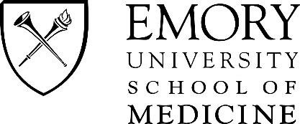

INTERNATIONAL VISITING STUDENT APPLICATION CHECKLIST

CHECKLIST OF ITEMS THAT MUST BE SUBMITTED AS PART OF YOUR APPLICATION:

- Completed international visiting student application form
- Non-refundable $500 application fee in U.S. currency
- A current official transcript from your school
- A letter from your Registrar or Dean stating that you are in good standing (this letter also needs to specify that you will be in your final year of study and will have completed and passed the required core clerkships in medicine, pediatrics, obstetrics/gynecology, surgery, and psychiatry)
- Completed health forms:
Forms can be found using the link below: https://studenthealth.emory.edu/immunization/forms.html
- Proof of personal health coverage which provides coverage in the United States, and specifically in Georgia
- Proof of medical liability and/or malpractice insurance covered by your home school during the elective time (minimum of $1 million per occurrence/$5 million aggregate liability)
- Color Copy of the main pages of your passport showing, passport number, dates of issue, expiration, photo, date of birth and place of birth
- 2 passport size/quality photographs
- Documentation of an international criminal background check through an Emory preferred background check provider:
http://www.advantagestudents.com http://www.infomart-usa.com
- Proof of passing USMLE Step 1
- Color copy of students current B-1 Visa
- If a student from a non-English speaking country, TOEFL iBT test (Test of English as a Foreign Language) results

